

**ABHINAV VIJAYAKUMAR**

**19BCE1311**

**CSE3506 – ESSENTIALS OF DATA ANALYTICS LAB-2**

**DR. LAKSHMI PATHI JAKKAMPUTI (L21 + L22)**

**--------------------------------------------------------------------------------------------**

**Tasks for Week-2: Forecasting**

**Understand time-series operations/functions and forecast the annual gold price & gdp growth rate of India based on given instructions.**

**Aim**: To develop a forecasting model that forecasts the value 24 units ahead of time

**Algorithm:**

1. Set the working directory
2. Convert the dataset into time-series data using the ‘ts’ function.
3. Using acf and pacf check if the data is stationary visually, if the readings are below the blue line then the data is stationary
4. Using adf.test check if the data is stationary using p-value.
5. Using auto ARIMA, find out which model is the best.
6. Pass the best model to the forecast function so that the forecasting is done with 95% confidence for the next 24 units of data.

**Inference:**

**i) For Gold Prices:**

The given data is not stationary. We can see this using p value and acf and pacf graph.

p-value = 0.4359

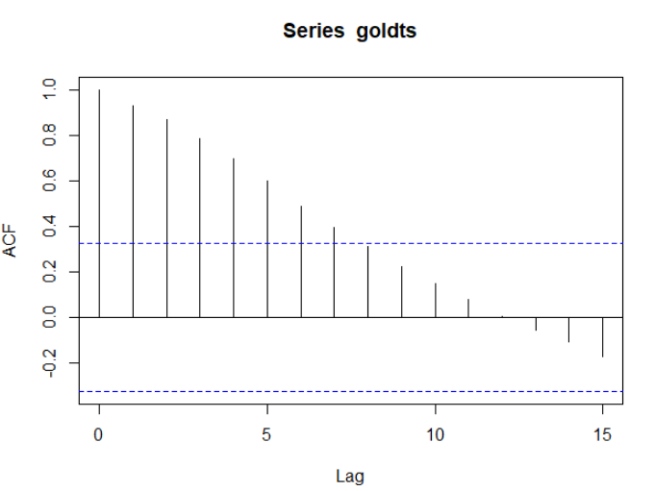

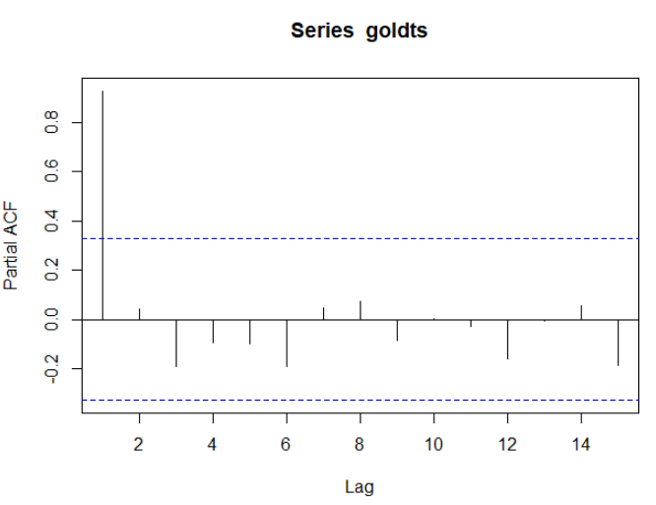

**Best ARIMA Model:**

**Auto ARIMA**ARIMA(2,1,2) with drift : Inf

ARIMA(0,1,0) with drift : 457.5809

ARIMA(1,1,0) with drift : 459.3633

ARIMA(0,1,1) with drift : 459.385

ARIMA(0,1,0) : 459.9305

ARIMA(1,1,1) with drift : 461.3121

Best model: ARIMA(0,1,0) with drift

**Accuracy of the Model:**

**ME RMSE MAE MPE MAPE MASE ACF1**

**Training set** 0.08218409 155.5098 116.6965 -0.1799051 2.960037 0.9286895 -0.07882193

**ii) For gdp.csv:**

The given data is stationary. We can see this using p value and acf and pacf graph.

p-value = 0.01

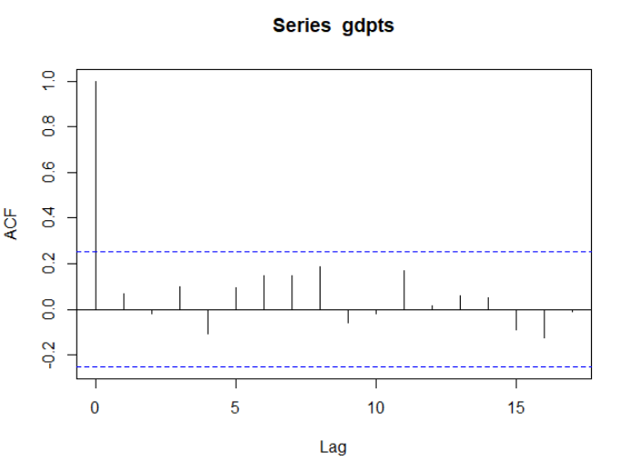

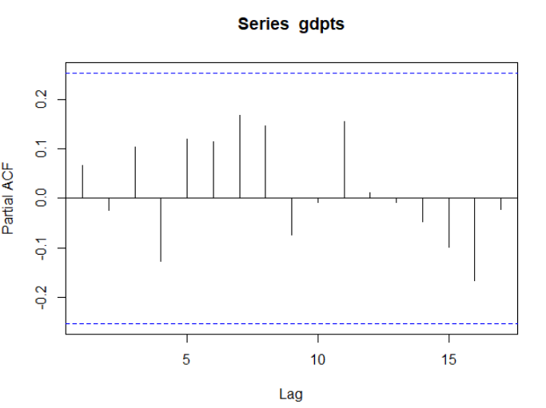

**Best ARIMA Model:**

**Auto ARIMA**ARIMA(2,1,2) with drift : Inf

ARIMA(0,1,0) with drift : 341.4397

ARIMA(1,1,0) with drift : 332.4653

ARIMA(0,1,1) with drift : Inf

ARIMA(0,1,0) : 339.554

ARIMA(2,1,0) with drift : 326.0715

ARIMA(3,1,0) with drift : 327.9755

ARIMA(2,1,1) with drift : Inf

ARIMA(1,1,1) with drift : Inf

ARIMA(3,1,1) with drift : Inf

ARIMA(2,1,0) : 324.2097

ARIMA(1,1,0) : 330.5929

ARIMA(3,1,0) : 326.1139

ARIMA(2,1,1) : 317.8228

ARIMA(1,1,1) : 316.651

ARIMA(0,1,1) : 314.6516

ARIMA(0,1,2) : 316.6508

ARIMA(1,1,2) : 316.6275

Best model: ARIMA(0,1,1)

**Accuracy of the Model:**

**ME RMSE MAE MPE MAPE MASE ACF1**

**Training set** 0.2704179 3.287709 2.345416 121.6616 161.0542 0.7720211 -0.02667223

**Program:**

**i) For gold.csv:**

setwd("C:/Users/Abhinav Vijayakumar/Desktop/VIT Academics/Sem 6/Essentials of Data Analytics/LAB/LAB 2")

gold <- read.csv("gold.csv")

library(forecast)

library(tseries)

View(gold)

goldts<-ts(gold$Price, start = min(gold$Month), end = max(gold$Month), frequency = 1)

class(goldts)

plot(goldts)

acf(goldts)

pacf(goldts)

adf.test(goldts) # stationary only if p value <0.05

# To make it stationary, differentiate

goldmodel=auto.arima(goldts, ic='aic', trace = TRUE)

goldf=forecast(goldmodel, level=c(95), h=24)

goldf

plot(goldf)

accuracy(goldmodel)

**ii) For gdp.csv**

setwd("C:/Users/Abhinav Vijayakumar/Desktop/VIT Academics/Sem 6/Essentials of Data Analytics/LAB/LAB 2")

gdp <- read.csv("gdp.csv")

library(forecast)

library(tseries)

View(gdp)

gdpts<-ts(gdp$GDP_gr, start = min(gdp$Year), end = max(gdp$Year), frequency = 1)

class(gdpts)

plot(gdpts)

acf(gdpts)

pacf(gdpts)

adf.test(gdpts) # stationary only if p value <0.05

# To make it stationary, differentiate

gdpmodel=auto.arima(gdpts, ic='aic', trace = TRUE)

gdpf=forecast(gdpmodel, level=c(95), h=24)

gdpf

plot(gdpf)

accuracy(gdpmodel)

**Result:**

**Forecast for gold prices:**

**Point Forecast Lo 95 Hi 95**

37 5081.371 4767.741 5395.001

38 5138.743 4695.203 5582.283

39 5196.114 4652.891 5739.338

40 5253.486 4626.226 5880.746

41 5310.857 4609.559 6012.155

42 5368.229 4599.995 6136.462

43 5425.600 4595.813 6255.387

44 5482.971 4595.892 6370.051

45 5540.343 4599.453 6481.233

46 5597.714 4605.929 6589.500

47 5655.086 4614.892 6695.279

48 5712.457 4626.011 6798.904

49 5769.829 4639.019 6900.638

50 5827.200 4653.704 7000.696

51 5884.571 4669.887 7099.255

52 5941.943 4687.423 7196.463

53 5999.314 4706.184 7292.444

54 6056.686 4726.066 7387.305

55 6114.057 4746.975 7481.139

56 6171.429 4768.832 7574.025

57 6228.800 4791.566 7666.034

58 6286.171 4815.116 7757.227

59 6343.543 4839.426 7847.660

60 6400.914 4864.447 7937.382

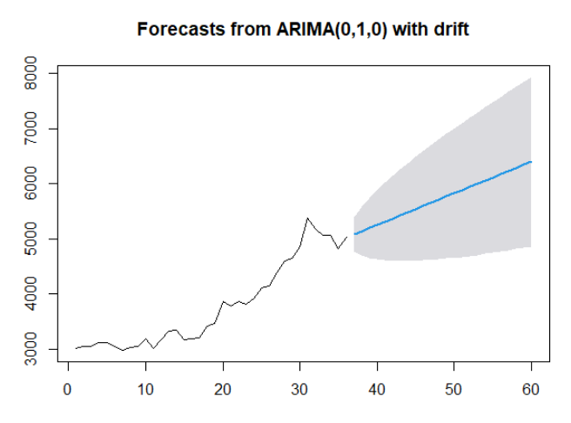

**Forecast for gdp:**

**Point Forecast Lo 95 Hi 95**

2021 5.177274 -1.376684 11.73123

2022 5.177274 -1.401989 11.75654

2023 5.177274 -1.427197 11.78174

2024 5.177274 -1.452309 11.80686

2025 5.177274 -1.477327 11.83187

2026 5.177274 -1.502250 11.85680

2027 5.177274 -1.527082 11.88163

2028 5.177274 -1.551821 11.90637

2029 5.177274 -1.576470 11.93102

2030 5.177274 -1.601029 11.95558

2031 5.177274 -1.625500 11.98005

2032 5.177274 -1.649882 12.00443

2033 5.177274 -1.674178 12.02873

2034 5.177274 -1.698389 12.05294

2035 5.177274 -1.722514 12.07706

2036 5.177274 -1.746555 12.10110

2037 5.177274 -1.770513 12.12506

2038 5.177274 -1.794389 12.14894

2039 5.177274 -1.818183 12.17273

2040 5.177274 -1.841896 12.19644

2041 5.177274 -1.865530 12.22008

2042 5.177274 -1.889085 12.24363

2043 5.177274 -1.912561 12.26711

2044 5.177274 -1.935960 12.29051

